December 2010

Dear Family & Friends,

Warm Christmas and New Year greetings from all the McLeans. We are grateful to God for many blessings throughout 2010, and trust that you have been blessed in numerous ways too. This past year we were all "on the move", even more than usual.

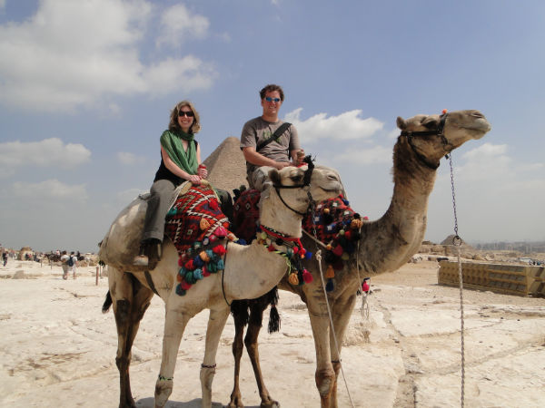
Andrew and Heather were able to take an extended leave from work, January-March, so they could travel and explore the wonders of God's world. They had a marvelous time visiting: New Zealand, Australia, Hong Kong, China, Taiwan, Singapore, Kenya, Tanzania, Egypt and Turkey. They enjoyed touring parts of China with Heather's cousin Colleen, while Andrew introduced Heather to Taiwan, the land of his childhood, and to various family friends there. In Africa they climbed to the top of Mount Kilimanjaro and explored the pyramids. Istanbul was a late add-on to their trip, but turned out to be an unexpected highlight and a very fascinating city. They have settled back into their cozy bungalow (15 minutes drive from our house) and are serving others through their paramedic and nursing work at Sunnybrook Health Sciences Centre, plus various church activities.

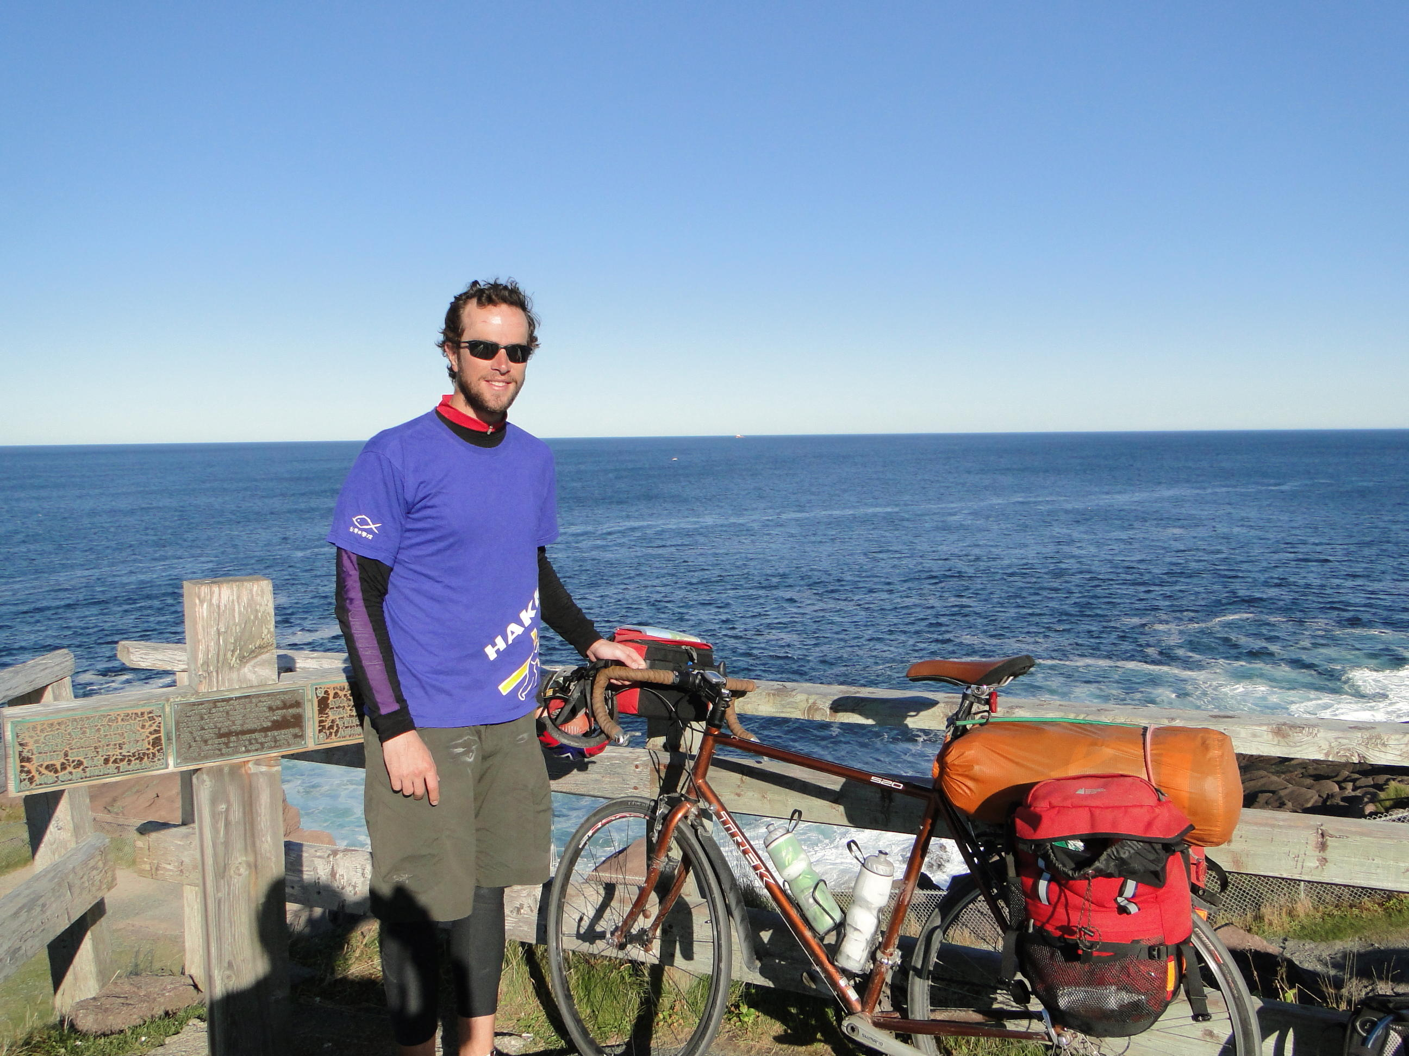
Peter felt the need for a change after two years of happy though predictable living at home and working at BioPed Footcare. So why not buy a new Trek touring bicycle and ride solo across Canada?! Add to the strenuous physical exertion, an underlying spiritual component of learning to trust and rely more on God for daily living, and you end up with Peter's Great Canadian Cycling Adventure. Between June 18 and October 9, Peter flew to Vancouver Island, then cycled across beautiful British Columbia and the Rocky Mountains, Alberta and the prairie provinces, Ontario, Quebec, the Maritimes, and finally Newfoundland to Cape Spear (seen at right), before flying back home in time to celebrate Thanksgiving. You can still read his insightful journal entries and stories about his many fascinating experiences on his blog (http://petermclean.tumblr.com) as well as see gorgeous photos of God's amazing creation. Another dimension to Peter's bike ride, was raising money to help publish the Hakka Bible in Taiwan. Family and friends in Canada and the United States donated CDN$18,000, while people in Taiwan donated another CDN$9,000 in honour of Peter's 9000KM adventure. To God be the glory! Peter just received news that he has a new job starting in January 2011 as a pedorthist in the Okanagan Valley in south-central BC (www.okaped.com). May God continue to bless him as he ventures out on his own.

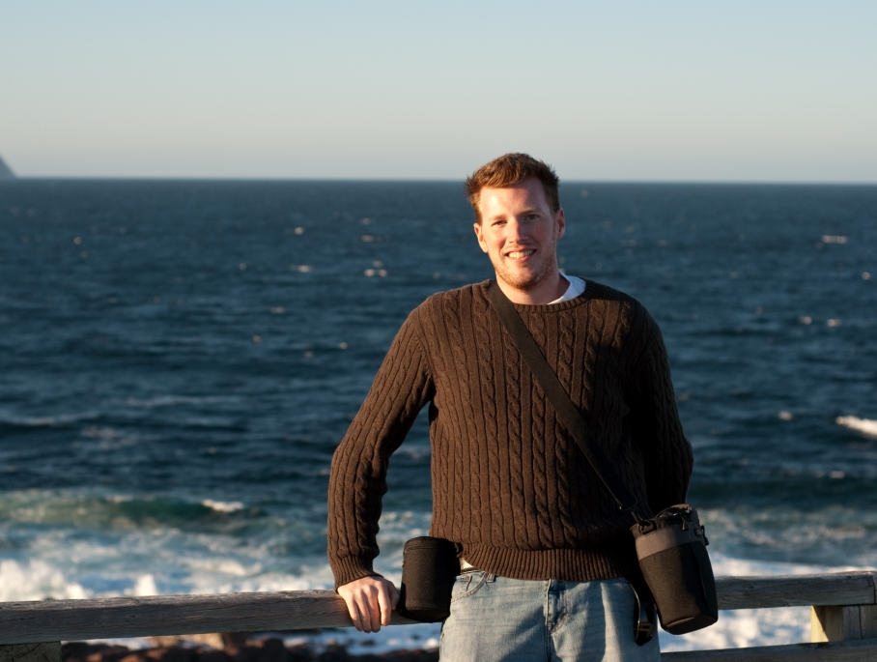
In October, Mark received his Bachelors in Business Administration from Wilfrid Laurier University in Waterloo. He looks back over his 4 years there with many happy memories. Some of those include working and volunteering with two growing social ventures, Sustainable Waterloo (www.sustainablewaterloo.org) and Students Offering Support (www.studentsofferingsupport.ca). Mark was also on the move in 2010, with short trips to St. Louis (Urbana 2009), San Diego (to visit friends made at Urbana), Nicaragua (sponsored by Students Offering Support), Boston, San Francisco and St. John's Newfoundland (seen at left, to celebrate the end of Peter's bike trip). The big news for Mark is that he has landed his first full-time job. Next month he will move to Cambridge, Massachusetts where he will serve as a Research Analyst for a young energetic company called the Center (not spelled Centre as we do in Canada) for Effective Philanthropy (www.effectivephilanthropy.org). He is very excited about moving to the Boston area, and learning how to honour God and serve others by putting his Business degree into practice. So the last of our 3 young birds will soon be leaving the nest. We shall miss life together with Mark and Peter here at home.

Paul flew back-and-forth to Taiwan for three 6-week working visits in: Jan/Feb, May/June and Oct/Nov. He and the Hakka Bible translation team made very good progress. By God's grace they were able to finalize their translation of: the 12 Minor Prophets, Proverbs, the Psalms, Mark's Gospel and Matthew 1-17. They hope to complete their review of the rest of the New Testament by the summer of 2011, then move into final typesetting and proofreading modes before publication in 2012, the Presbyterian Church in Taiwan's Year of Hakka Mission. Paul enjoyed visiting Hakka friends and preaching in various Hakka churches each visit. A major highlight in Taiwan was the 90th birthday celebration for Elder Liau Tet-thiam who has been a faithful coworker for 25 years.

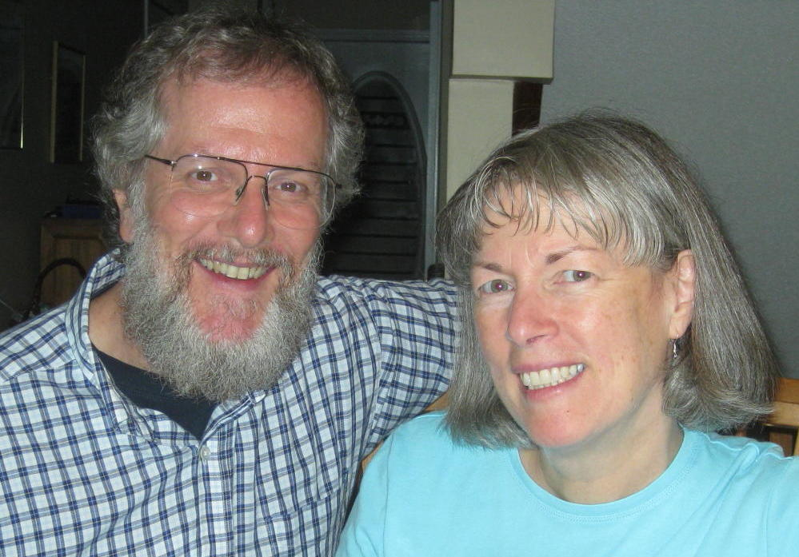
Mary Beth enjoys working 4 days a week at the Presbyterian Church in Canada's General Assembly offices, a half hour's walk from our home. She was very busy at Knox Church this past year where she serves as a Trustee, a member of the Personnel Committee, and as coordinator of the prayer chain. We, Mary Beth and Paul, were on the move together, as we celebrated our 30th wedding anniversary all year long. We enjoyed short trips to Niagara-on-the-Lake and Stratford to see plays by GB Shaw and Shakespeare. For summer holidays we drove via Ottawa and Quebec City to New Brunswick where we attended the 60th birthday party for Mary Beth's brothers Paul and Bill, and brother-in-law Jack. We visited Prince Edward Island to attend the wedding of Jack and Judi's son Samuel to Maria O'Brien, and to attend a family reunion near North Rustico. We also saw a performance of Anne of Green Gables in the historic city of Charlottetown. On Labour Day weekend we flew with Andrew to Los Angeles where we attended David and Angela Tseng's wedding. David lived with us for 3 years in Taichung when the boys attended elementary school.

We are looking forward to a joyful family Christmas this year, before we have to say "goodbye" and "God be with you" to Peter and Mark. The Good News is that Jesus Christ truly is Emmanuel—"God with us", whether we are on the move or at home, no matter where we live or serve.

May Jesus Christ, the Light of the World, shine in your hearts and homes this Christmas and throughout the New Year.

Love from us all,
Paul, Mary Beth, Andrew & Heather, Peter and Mark

