Christmas Greetings 2010 聖誕快樂 新年祝福
明星燦爛夜未央，伯利恆城在睡鄉，野外牧人見異象，天上皎然發大光

Midnight sleeping Bethlehem is a lovely Chinese carol I re-heard recently. You can hear it at http://www.hymncompanions.org/Dec/21/stream.php as my Christmas gift to you.

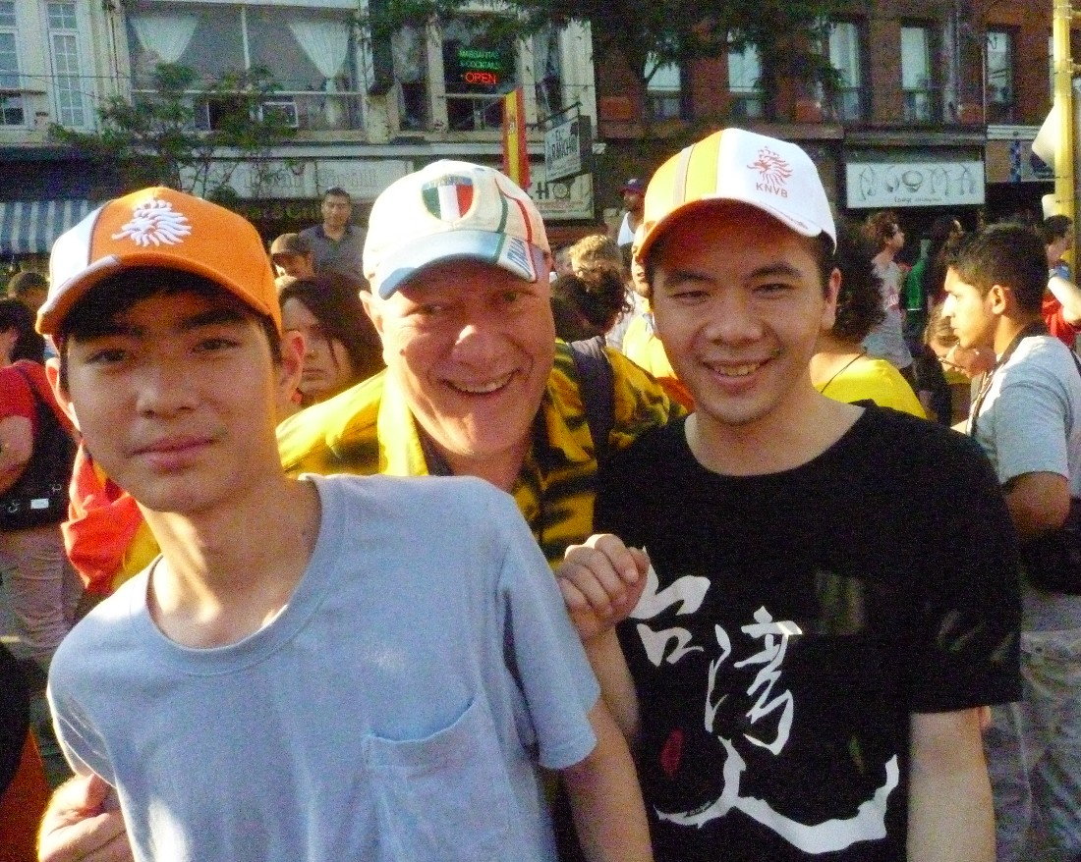
As I write this I realize my 2010 looks a lot like 2009 – so I am tempted to refer you to last year’s letter. But the similitude of 2010 had its own joys, and I am thankful for them. It was filled with busy-ness of what I call ‘semiretirement”, to save breath when people ask “but what actually do you DO?”. I enjoyed two paid trips to Taiwan in June and November thanks to George Leslie Mackay, whose cause has kept me at work in the Canadian Mackay Committee. I did a paper on his letters at a conference in Taiwan in June, lectured, and preached in Taiwanese (a first!) in pouring rain at the 台灣公義行動 Justice Action street church in Taipei. In November I accompanied a Pipe Band to Tamsui. Two ongoing projects are planning celebrations of the 130th anniversary of Tamsui Oxford College in 2012, organizing a campaign to get a stamp for it, and being part of a team editing 30 years of Mackay’s letters for publication. If you don’t know who Mackay is by now shame on you!
Dutch fans celebrating anyway on College Street

As President of the Taiwanese Human Rights Association of Canada I visited imprisoned President Chen in Taiwan, rallied in the cold at China’s Consulate, lobbied against Harper’s hate law C-23 – all to no visible change, and I am tired. It is good to see reflect on all this at Christmas remembering the weakness of the infant Messiah in the face of the same evil, and be willing to be to faithful and not to worry about being “successful”.

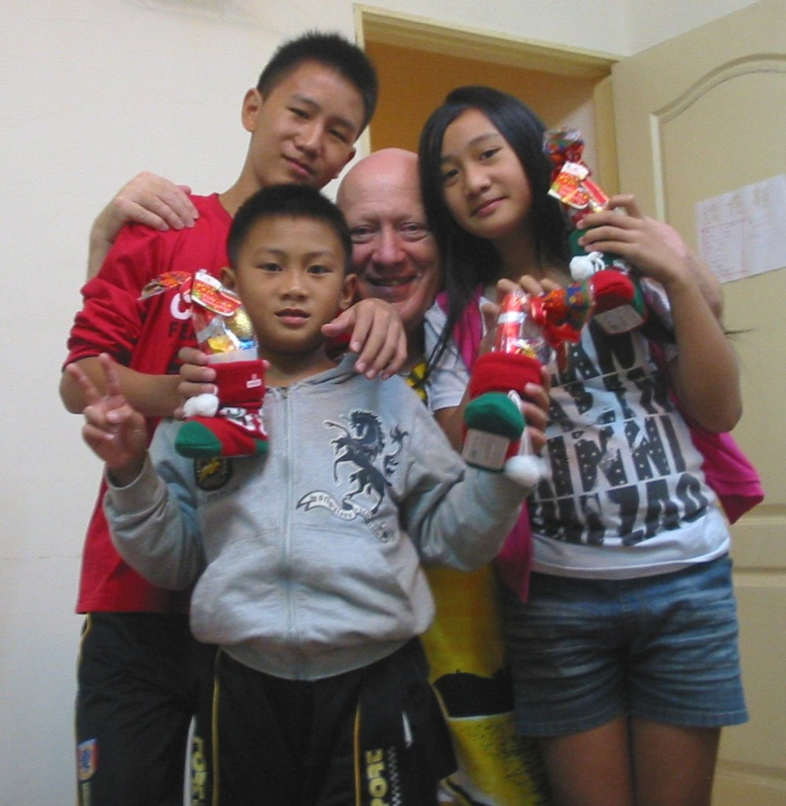
I still have a nice office at York Centre for Asian Research. I organized a panel on “Working for Human Rights in China from Outside of China” at the Canadian Asian Studies Association in Ottawa , and arranged a talk at York by DPP elder You Si-kun. And finally got “George Leslie Mackay and the Poll Tax” published. You can read it at http://web.usm.my/ijaps/default.asp?tag=2&vol=11

In Taiwan I visited my Bunun god-grandchildren and my four Tayal godsons. In November I missed the birth of my Tayal god-grandson – Michael - by 4 days. Here in Canada I enjoyed skating and trips with Chinese friends– we saw moose in Algonquin and airplanes in Ottawa. I celebrated my 62nd birthday with “Doctor’s Dilemma” at the Shaw Festival with Mengting. We hup-hup-ed for Holland, did “Peter Pan” at Stratford, Beaches Jazz, Praetorius Vespers, & Opera Tea. So a lot like 2009 but I am not complaining, and I wish all of you an equally happy 2011. Michael
With my god-grandchildren

Michael Stainton 45 Fontainbleau Drive, Toronto, Canada, M2M 1P1 michaels@yorku.ca

