Christmas Greetings 2012 聖誕快樂 新年祝福
How to start? On January 1 weighed 202 pounds on mom and dad’s old bathroom scale. December 8 it says 200. In between I once got down to 194. Such is the executive summary of 2012. To you with too many cards to read, I release you with my Christmas blessing and words on the meaning of Christmas, from Phillip Doddridge (1702-1751):

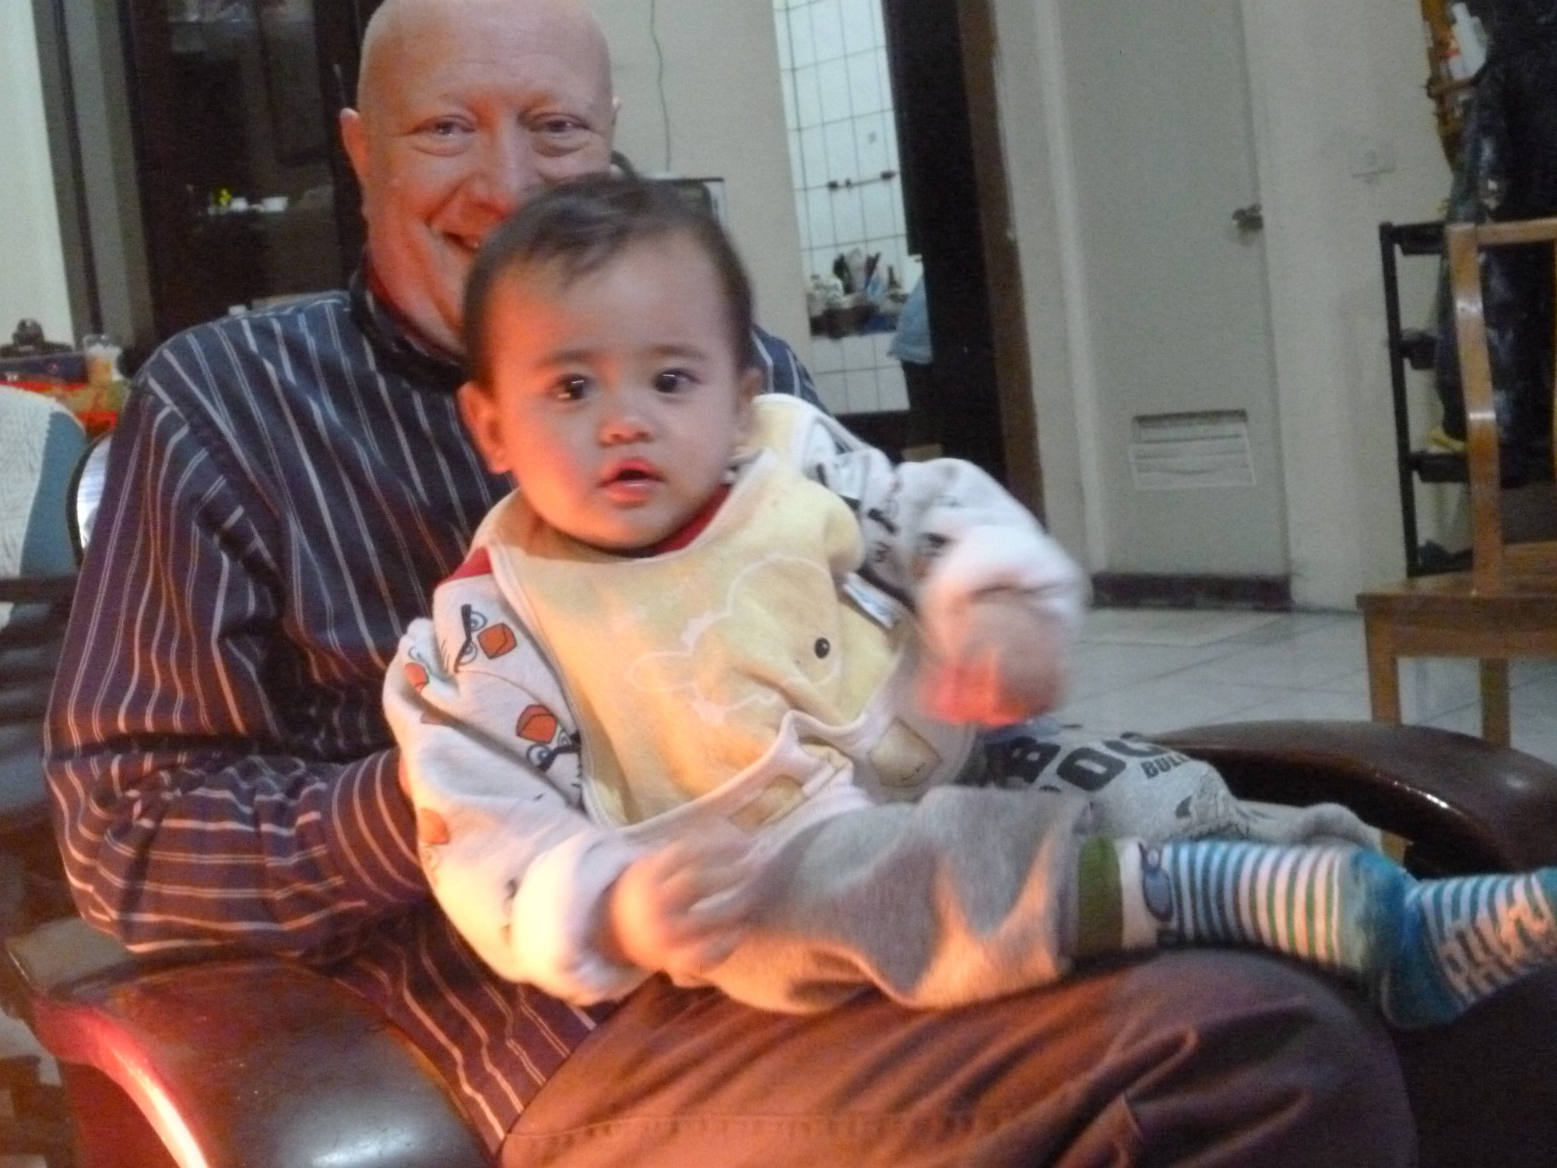He comes, the prisoners to release in Satan’s bondage held;
The gates of brass before Him burst, the iron fetters yield.
He comes the broken heart to bind, the bleeding soul to cure,
and with the treasures of his grace to bless the humble poor.

For those of you with more leisure, here are some highlights of the year between 202 and 200. Being part of a Canadian observer group of Taiwan’s January 14 election, then spending Lunar New Year with my Aboriginal godsons and grandchildren is certainly the big news of 2012. Here’s my new Tayal grandson – Leliou Batu , aka Little Michael. Back in Canada the election provided a colloquy at York Centre for Asian Research, where I still have an office; and the speaker for the annual meeting of the Taiwanese Human Rights Association of Canada, me still president. Our website is thracanada.blogspot.ca. Working for human rights in Taiwan, China, and Canada continues to be much of my life.

During the spring I had the paternal joy of supporting Mengting in his job search, celebrating his graduation from McMaster, and seeing him start his career as an engineer in Niagara Falls. I am grateful to Nick and my Aboriginal sons for adopting me, giving me empathy with those whose newsletters run on about their grandchildren, or children’s achievements. At the far end of life, Spring took away the last of my father’s generation - aunt Helen; also cousin Trecia; and the two eldest granddaughters of George Leslie Mackay, Anna and Isabel. Happily Margaret Mackay is still with us at 94 and among the times I enjoyed with her this year was seeing “The Iron Lady” then going for fish and chips.

Still secretary for the Canadian Mackay Committee, in June I shared a milestone, organizing book launches in Toronto and in Woodstock for Series 1 (of 3) of his letters. I have had several “free trips” to Taiwan these few years thanks to this project, but the progress of Louise Gamble’s editing means there will likely be no more. New projects arise however. One is rediscovering my maternal Hitch family. In August we had a small Hitch picnic in the Royal Botanical Gardens, close to Uncle Don (last of my mother’s siblings) and had such fun we did another reunion in November. In between I spent weekends at cousin Janet’s home in London scanning hundreds of slides into computer images, reliving those memories. Like my lost efforts as a piano student at the Ursuline Music School in Windsor in 1962.

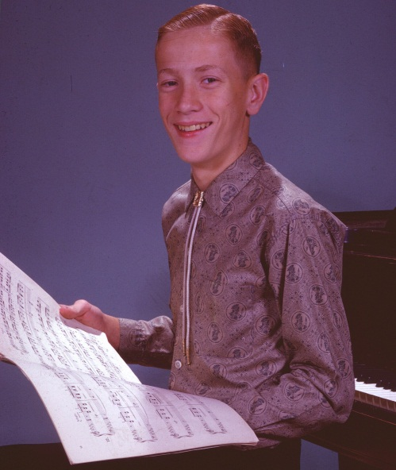Buying a laptop in May caused changes in my life. Freed from cursing the slow old desktop I spend a lot more time on line, relaxed on the sofa putting pictures on Facebook, and doing endless revisions of our church service schedule, as I am back on Taiwanese United Church board, responsible for worship. I get off the sofa to swim, skate, workout, or walk in the nearby conservation area. All recorded in Facebook albums. And many wonderful concerts with two musical and engineering geniuses Daniel Ho and Daniel Li; plays at the Shaw festival with Mengting, and picnics and trips to the Kawarthas and Algonquin with Taiwanese friends. In the summer I organized two petitions to keep the sauna at the aquatic centre where I swim and sweat with other seniors. Success!

Michael Stainton, still at 45 Fontainbleau Drive, Toronto, M2M 1P1 and michaelpayas@gmail.com

