CHRISTMAS 2012

Dear Friends and Family,
2012 has again been a busy year. I hardly know where to begin. It seemed like 2012 was only about three months long!
Mom had a bad few weeks in February/March and I feared she was giving up. She fought back but still not eating much. She still loves her chocolate. I look for chocolates that do not have nuts nor need to be chewed. We celebrated her 95th birthday in May and she shone like a bright light all afternoon. Below is a picture of her on that occasion with my cousin Debbie who came from NB to celebrate with us. She seems content and very occasionally asks when she will go home.
I am doing very well. I was going for physio three times a week when my bulged disk first happened. Now I am down to once every two weeks. Hopefully within a few weeks I will no longer have to go. Otherwise, I am well but feeling the pains and creaks of a 75 year old!
Again it has been a sad year for both the Nichol and Welsh families. First my cousin Dalton’s wife Shirley died very suddenly just six months after Dalton. I also lost my cousins - Catherine Turner, Dalwin Millard, Daniel Welsh, and my Aunt Barb Nichol. I did all of the latter funerals. I went to NB in August to bury my Aunt Jessie’s ashes and at that time was able to do Daniel’s funeral as well. My Taiwan missionary community mourns the passing of our good friend the Rev. Murray Garvin.
This has again been a travelling year, going to India in January for the dedication of the new Mendha Church and then in March and again in September to Taiwan. Below is a picture of Dr. and Mrs. Kao during this visit. It was so good to see them, although all too briefly.
Always some special celebrations each year
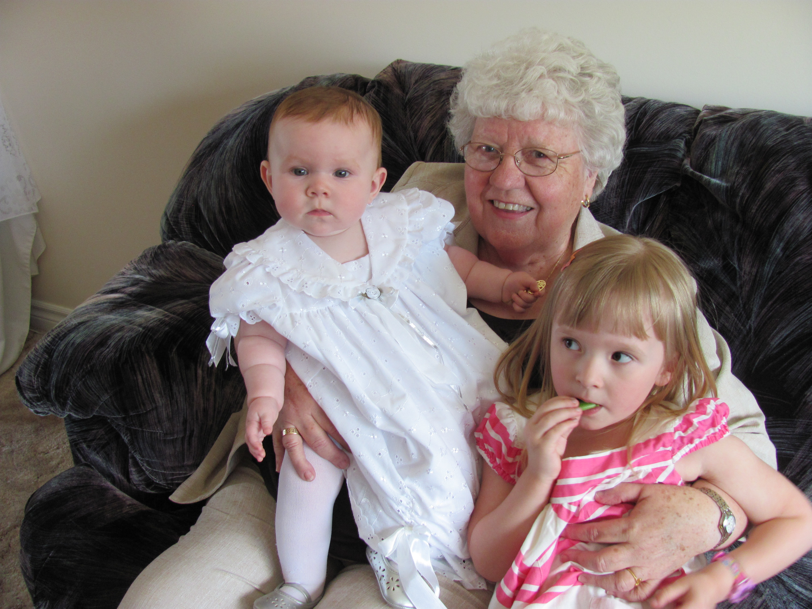
- Tim and Kim’s (my sister Dianne’s son) daughter was baptized – I am adding a picture of that wonderful event. She is now running around. It is hard to believe that she is now 15 months old. Cassie her big sister (now almost five) is great with her. They look so much alike.
- Carole Ann’s daughter Kim and Dave (Spira) were married in August. It was a wonderful wedding despite the invasion of rain. I was able to take mom.
- Sue and Paul’s daughter Lisa married to Li Chang will be first time parents in April – it’s a boy!
- My good friend Rick Allen was home for a couple of weeks in the summer. It was good to see him again.
- Pauline Brown was also here from India and we had lots of good times and visits. Usually when Pauline comes we go to visit long time friends and we did this again this year.
I am continuing to act as Convener of the International & Ecumenical Visitors Committee for the Presbyterian Church’s Women’s Gathering. The second one will be held in May of 2014. Very soon I will be getting busy extending invitations on behalf of the Women’s Gathering Committee. We look forward to a wonderful event again.
I am involved with my friend Joy Randall in researching the history of the educating of the girl child in Taiwan. Hopefully this project will be completed in the next few weeks and off to Taiwan for printing.
Being Clerk of the Presbytery of Waterloo-Wellington has really kept me busy this fall. Normally we have two meetings but had about ten extra ones this fall. I am learning lots about Church law and legalese.
My feline family is doing well. Sam thinks I only have time for him – wants to be on my knee all the time. Princess could care less as long as she gets fed and Snoopy is as sweet and docile as ever. He still likes to jump (docile??) on the bird cage and Sally and Joey (cockatiels) are not too impressed but he no longer frightens them.
I hope you don’t mind receiving this electronically. Merry Christmas to you and your family. May you know the peace of the season and the reason for the season.
With love to all from both Mom and I,
Wilma
+-My address is –
A505-457 Edinburgh Road South, Phone - 519-822-9496
Guelph, ON N1G 2Y5 Canada – Email - wilma.welsh@rogers.com
